Martha Wetzel

ECON 771

Assignment 1

1. Table 1 shows descriptive statistics for hospital revenues and uncompensated care over time. In general, uncompensated care costs varied widely among hospitals, ranging from $0 to over $800 million. Uncompensated care costs were higher in the 2010s than in the 2000s, with the means peaking at $10 million in 2012-2013. In contrast, mean total revenue strictly increased between 2003 and 2019.

| **Year** | **N** | **Mean** | **SD** | **Min** | **Max** |
| --- | --- | --- | --- | --- | --- |
| **Uncompensated Care Costs** | | | | | |
| 2003 | 2,787 | 5,201,727 | 17,027,331 | 0 | 540,531,731 |
| 2004 | 2,721 | 5,383,004 | 14,918,444 | 0 | 383,115,254 |
| 2005 | 2,542 | 5,768,353 | 12,728,605 | 0 | 262,513,310 |
| 2006 | 2,419 | 6,811,845 | 15,739,458 | 169 | 290,672,092 |
| 2007 | 2,414 | 7,108,987 | 14,708,297 | 1 | 320,766,779 |
| 2008 | 2,474 | 8,043,861 | 17,440,082 | 0 | 356,080,833 |
| 2009 | 2,528 | 7,871,083 | 14,584,458 | 0 | 350,066,973 |
| 2010 | 2,781 | 8,259,195 | 20,576,701 | 0 | 806,862,611 |
| 2011 | 2,292 | 9,834,141 | 22,313,430 | 7,866 | 651,015,035 |
| 2012 | 2,565 | 10,011,277 | 23,829,541 | 24,517 | 586,404,093 |
| 2013 | 2,661 | 10,017,196 | 21,164,845 | 18,992 | 504,095,890 |
| 2014 | 2,623 | 9,211,892 | 23,638,733 | 17,294 | 698,389,486 |
| 2015 | 2,652 | 8,158,868 | 22,752,802 | 19,066 | 660,578,943 |
| 2016 | 2,721 | 8,687,950 | 23,251,986 | 26,549 | 634,588,297 |
| 2017 | 2,485 | 9,181,995 | 24,361,367 | 5,667 | 666,583,690 |
| 2018 | 1,969 | 8,656,675 | 21,216,947 | 3,846 | 520,583,623 |
| 2019 | 1,665 | 9,921,281 | 23,329,359 | 9,484 | 480,815,058 |
| **Total Revenue (in Millions)** | | | | | |
| 2003 | 5,721 | 198 | 339.85 | -2 | 4,723 |
| 2004 | 5,796 | 219 | 380.47 | 0 | 5,526 |
| 2005 | 5,829 | 240 | 420.91 | 0 | 6,399 |
| 2006 | 5,791 | 265 | 466.14 | 0 | 7,784 |
| 2007 | 5,763 | 289 | 510.38 | 0 | 8,577 |
| 2008 | 5,783 | 314 | 558.56 | 0 | 9,294 |
| 2009 | 5,765 | 345 | 616.29 | 0 | 9,846 |
| 2010 | 5,788 | 370 | 663.25 | 0 | 10,185 |
| 2011 | 5,773 | 397 | 715.64 | -28 | 10,572 |
| 2012 | 5,817 | 422 | 769.56 | -12 | 11,865 |
| 2013 | 5,768 | 448 | 837.24 | 0 | 12,752 |
| 2014 | 5,769 | 482 | 909.15 | 0 | 13,376 |
| 2015 | 5,768 | 522 | 972.39 | 0 | 14,144 |
| 2016 | 5,777 | 567 | 1,065.69 | 0 | 15,619 |
| 2017 | 5,763 | 608 | 1,170.03 | 0 | 16,863 |
| 2018 | 5,728 | 659 | 1,290.59 | 0 | 18,677 |
| 2019 | 5,714 | 714 | 1,426.42 | 0 | 22,001 |

1. The figure below shows uncompensated care costs over time by for profit and non-profit status.

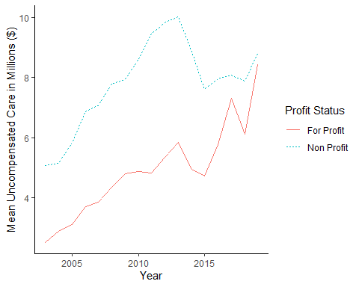

1. The following table shows the average effect of Medicaid expansion on uncompensated care costs, as estimated by a two-way fixed effects model. The estimated effects are all relatively similar to each other, ranging from a decrease of 4.30 to 5.30 million dollars.

|  | **All Expansions** | **2014 Expanders** | **2015 Expanders** | **2016 Expanders** |
| --- | --- | --- | --- | --- |
| Treatment | -4.90 | -5.09 | -4.39 | -5.30 |
|  | (0.80) | (0.90) | (1.14) | (0.89) |
| N | 42,299 | 37,035 | 20,461 | 18,888 |
| *Effect in millions ($) with standard errors in parentheses* | | | | |

1. The results of two event study analyses, one including all hospitals and one excluding hospitals from states that expanded after 2014, are presented below. While the point estimates differ slightly, both models show similar patterns. Both show some evidence of a decreasing trend in the treatment group two years prior to expansion and larger, significant decreases in uncompensated care in all years following expansion.

| **Year Relative to Expansion** | **All Expansions** | **2014 Expanders** |
| --- | --- | --- |
| -5 | 0.73 | 0.95 |
|  | (0.84) | (0.92) |
| -4 | -0.16 | -0.23 |
|  | (0.73) | (0.89) |
| -3 | -0.34 | -0.56 |
|  | (0.52) | (0.75) |
| -2 | -0.44 | -0.80 |
|  | (0.28) | (0.47) |
| 0 | -2.32 | -2.57 |
|  | (0.46) | (0.50) |
| 1 | -4.23 | -3.99 |
|  | (0.61) | (0.66) |
| 2 | -5.39 | -5.53 |
|  | (0.67) | (0.74) |
| 3 | -5.29 | -5.24 |
|  | (0.78) | (0.94) |
| 4 | -4.68 | -4.12 |
|  | (1.17) | (1.34) |
| 5 | -5.69 | -5.84 |
|  | (1.65) | (1.81) |
| N | 42299 | 37035 |

1. The table below shows a re-estimation of the model using the Sun and Abraham method.

| **Year Relative to Expansion** | **2014 Expanders** | **2015 Expanders** | **2016 Expanders** |
| --- | --- | --- | --- |
| -5 | 0.96 ( 0.88 ) | 0.56 ( 1.05 ) | -2.02 ( 3.45 ) |
| -4 | -0.55 ( 1.02 ) | 0.76 ( 0.82 ) | -1.81 ( 1.53 ) |
| -3 | -0.69 ( 0.74 ) | 1.52 ( 1.21 ) | -1.43 ( 1.99 ) |
| -2 | -0.74 ( 0.44 ) | 1.31 ( 0.5 ) | -1.43 ( 1.47 ) |
| 0 | -2.62 ( 0.49 ) | -0.88 ( 1.02 ) | -3.11 ( 0.95 ) |
| 1 | -4.02 ( 0.66 ) | -3.22 ( 1.36 ) | -6.68 ( 2.82 ) |
| 2 | -5.57 ( 0.75 ) | -3.91 ( 1.21 ) | -6.53 ( 3.24 ) |
| 3 | -5.27 ( 0.95 ) | -3.47 ( 1.54 ) | -8.56 ( 3.22 ) |
| 4 | -4.15 ( 1.34 ) | -5.19 ( 1.63 ) |  |
| 5 | -5.88 ( 1.8 ) |  |  |

1. The figure below shows the results from the Sun & Abraham method, aggregated across different years of expansion.

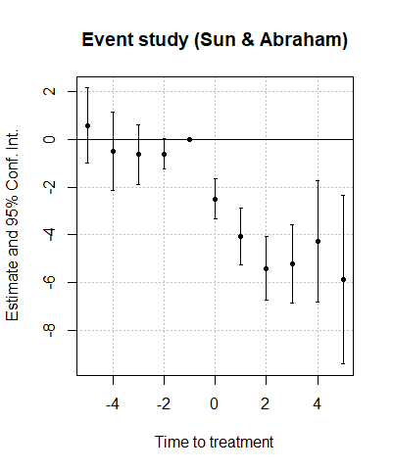

1. An alternative event study using the Callaway and Sant’Anna methods is shown below.

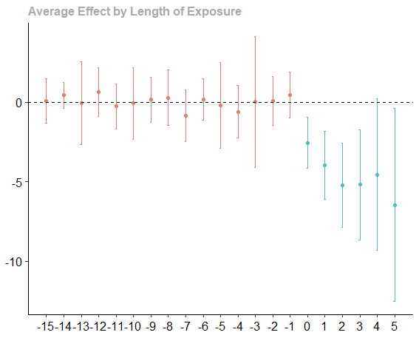

1. I couldn’t get this package to work, since it seemed to require a function called “basisVector,” which I wasn’t able to find anywhere other than a deprecated package that does not work with the version of R that I’m using.
2. In general, all of the specifications show decreases in uncompensated care following Medicaid expansion, particularly in the first few years following expansion. This is broadly the case across the different estimation methods and specifications. However, the results disaggregated by year suggest that the aggregated analyses may be missing some differences between the groups. Specifically, it would probably be instructive to run the “honest DiD” trends check on the disaggregated trends. The 2015 expanders seem to have higher uncompensated care costs relative to the never-expanders two years prior to expansion, while the 2014 and 2016 groups had insignificantly lower uncompensated care costs. Combining this different groups may hide some of the existing differences in the pre-period trends.
3. This was an extremely helpful assignment for me, since I need to use the new difference-in-difference methods in my own research. The most challenging aspect was honestly the programming, since I am not very good at R. That being said, I was surprised by how easy the implementation of most of these methods was, and a little concerned that I did not have a very good understanding of what was being done. Part of this is that I am accustomed to SAS, where more information about your models is printed by default. I especially felt like I did not understand the package that implemented the Callaway & Sant’Anna method very well. I was not terribly surprised that the different methods produced similar results, since I have heard from several sources that these methods tend to provide estimates in the same neighborhood.